SANSKAAR PATNI
180905134 CSE C 23
CN LAB 4

PART 1: STUDY OF DNS SERVER
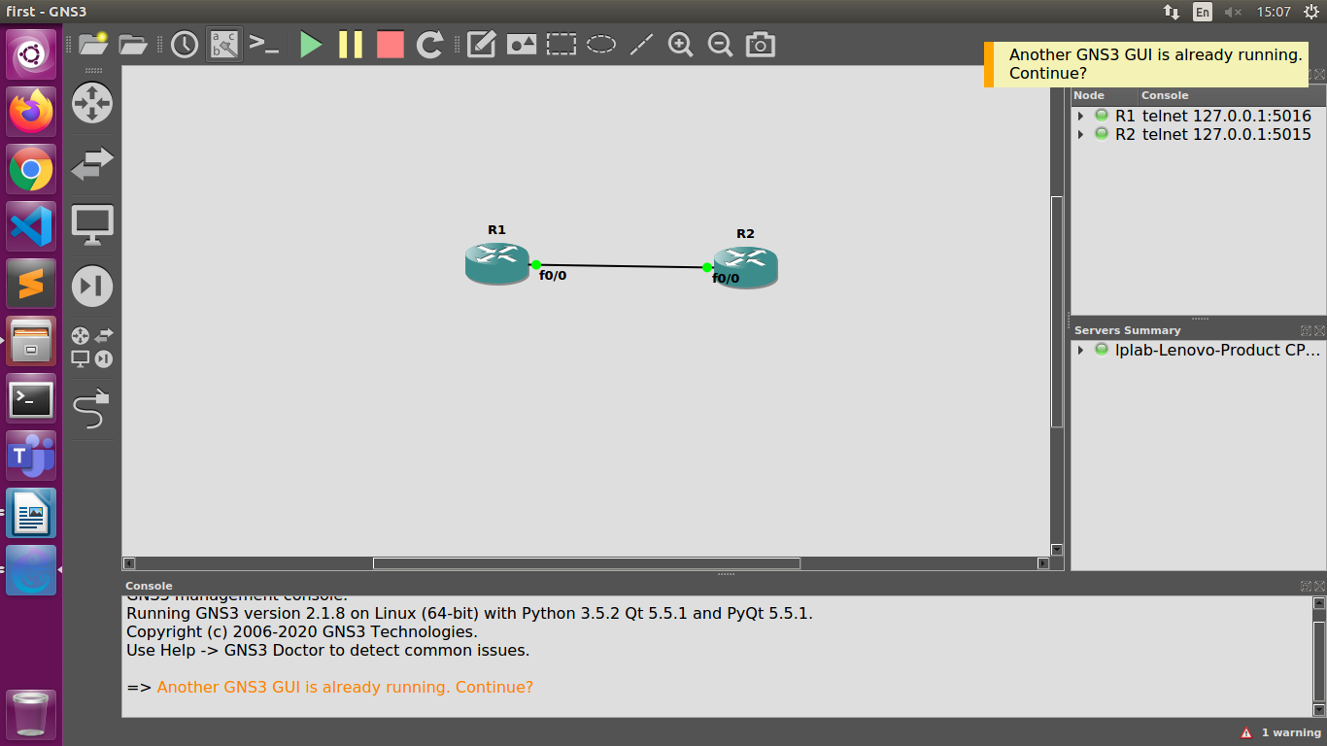
Configuring R2 as DNS Server and pinging loopback.R2.com from R1
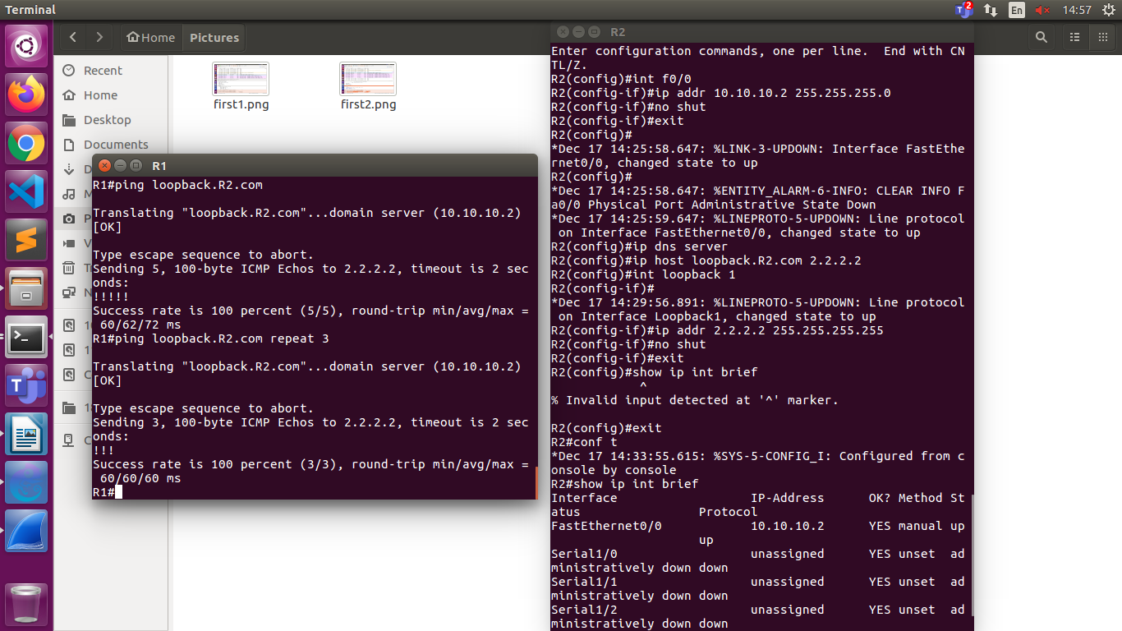
Wireshark output
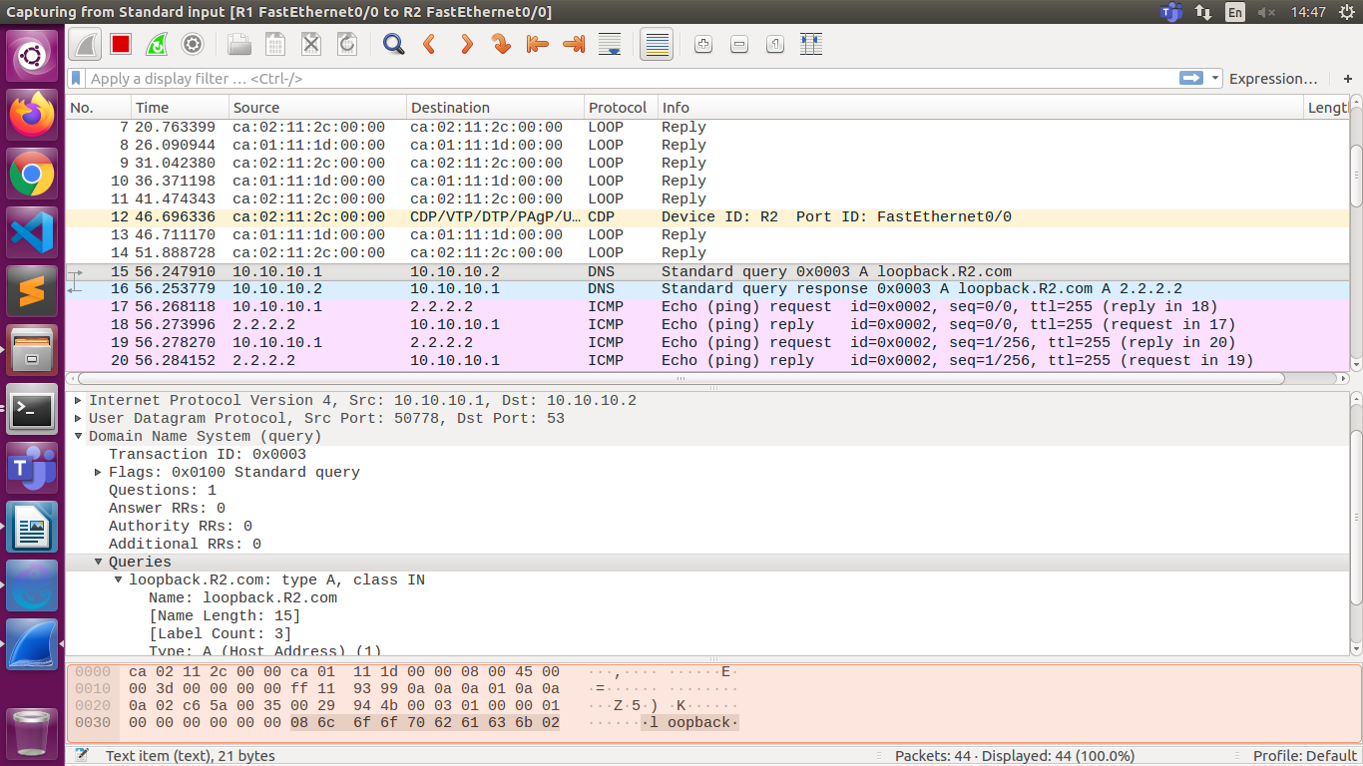
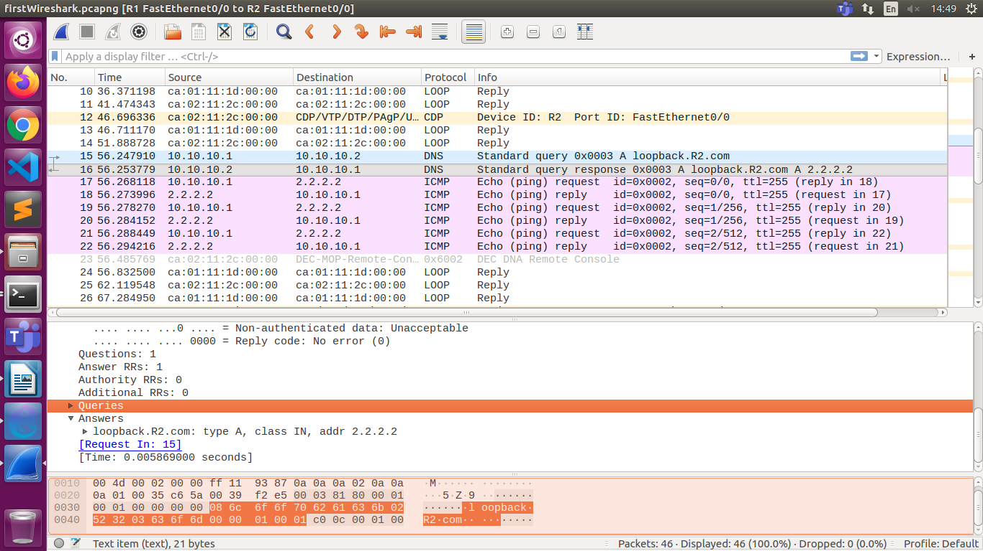
Adding PC
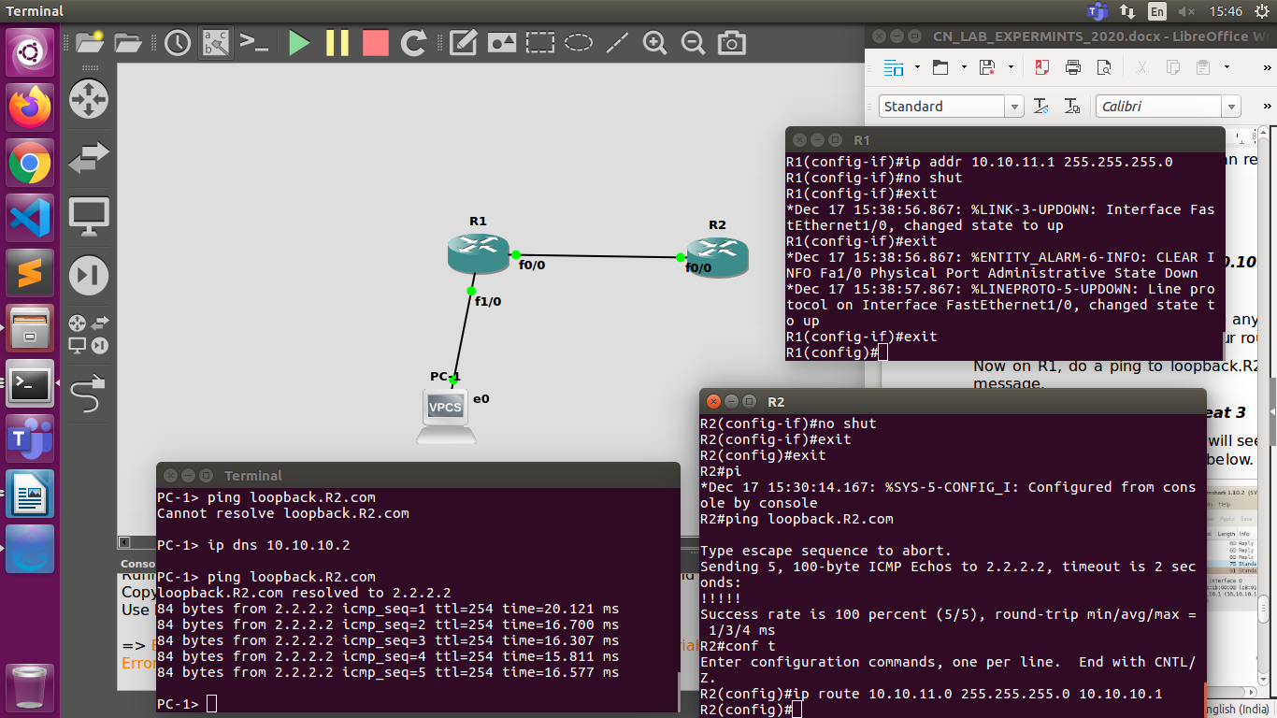
2.
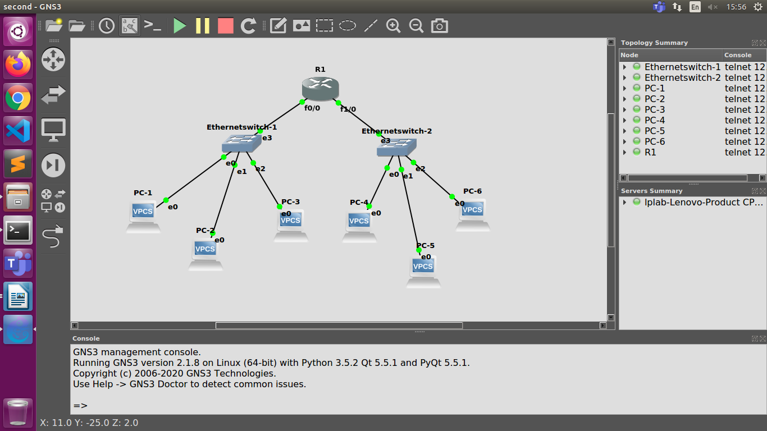
Configuring Router
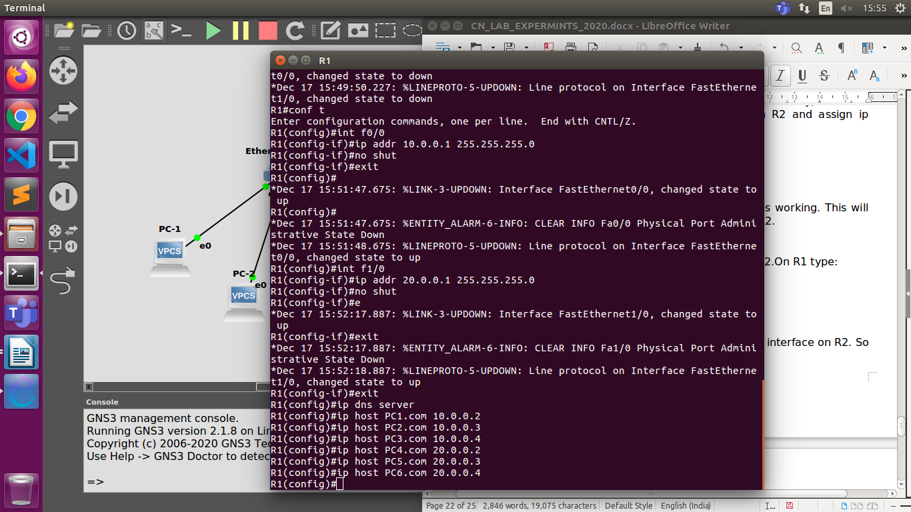
Configuring Pcs
PC-1> ip 10.0.0.2/24 10.0.0.1
PC-2> ip 10.0.0.3/24 10.0.0.1
PC-3> ip 10.0.0.4/24 10.0.0.1
PC-4> ip 20.0.0.2/24 20.0.0.1
PC-5> ip 20.0.0.3/24 20.0.0.1
PC-6> ip 20.0.0.4/24 20.0.0.1

PC-1> ip dns 10.0.0.1
PC-2> ip dns 10.0.0.1
PC-3> ip dns 10.0.0.1
PC-4> ip dns 20.0.0.1
PC-5> ip dns 20.0.0.1
PC-6> ip dns 20.0.0.1

ping PC2.com from PC1
PC-1> ping PC2.com
PC2.com resolved to 10.0.0.3
84 bytes from 10.0.0.3 icmp_seq=1 ttl=64 time=0.346 ms
84 bytes from 10.0.0.3 icmp_seq=2 ttl=64 time=0.324 ms
84 bytes from 10.0.0.3 icmp_seq=3 ttl=64 time=0.306 ms
84 bytes from 10.0.0.3 icmp_seq=4 ttl=64 time=0.296 ms
84 bytes from 10.0.0.3 icmp_seq=5 ttl=64 time=0.371 ms

ping PC6.com from PC1
PC-1> ping PC6.com
PC6.com resolved to 20.0.0.4
PC6.com icmp_seq=1 timeout
84 bytes from 20.0.0.4 icmp_seq=2 ttl=63 time=19.378 ms
84 bytes from 20.0.0.4 icmp_seq=3 ttl=63 time=15.061 ms
84 bytes from 20.0.0.4 icmp_seq=4 ttl=63 time=14.692 ms
84 bytes from 20.0.0.4 icmp_seq=5 ttl=63 time=15.674 ms
ping PC2.com from PC6
PC-6> ping PC2.com
PC2.com resolved to 10.0.0.3
PC2.com icmp_seq=1 timeout
84 bytes from 10.0.0.3 icmp_seq=2 ttl=63 time=20.296 ms
84 bytes from 10.0.0.3 icmp_seq=3 ttl=63 time=14.551 ms
84 bytes from 10.0.0.3 icmp_seq=4 ttl=63 time=15.210 ms
84 bytes from 10.0.0.3 icmp_seq=5 ttl=63 time=14.601 ms

ping screenshot
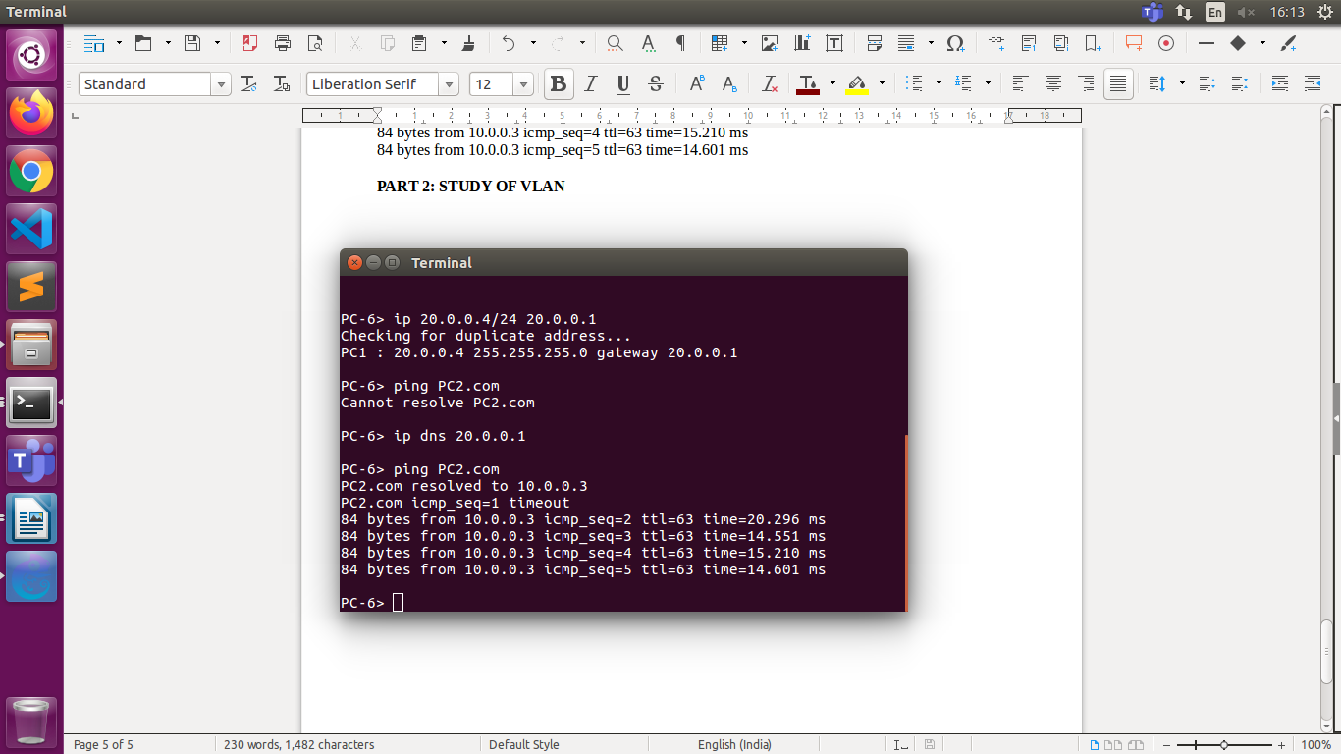

PART 2: STUDY OF VLAN
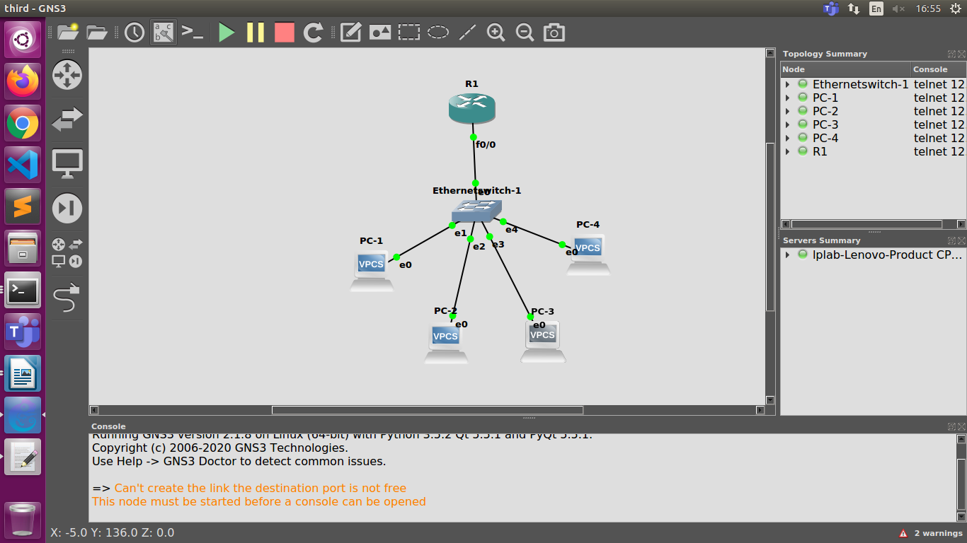

Router configuration
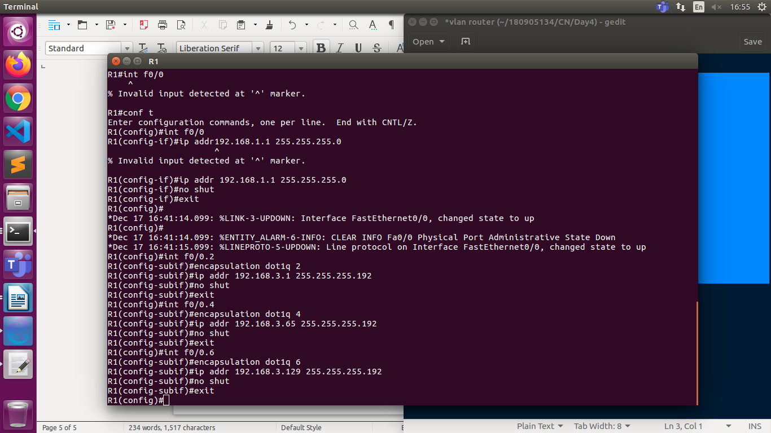
PC configuration:
PC-1> ip 192.168.3.2/26 192.168.3.1
PC-2> ip 192.168.3.3/26 192.168.3.1
PC-3> ip 192.168.3.66/26 192.168.3.65
PC-4> ip 192.168.3.130 255.255.255.192

ping pc1 to pc2
PC-1> ping 192.168.3.3
84 bytes from 192.168.3.3 icmp_seq=1 ttl=64 time=0.324 ms
84 bytes from 192.168.3.3 icmp_seq=2 ttl=64 time=0.310 ms
84 bytes from 192.168.3.3 icmp_seq=3 ttl=64 time=0.282 ms
84 bytes from 192.168.3.3 icmp_seq=4 ttl=64 time=0.329 ms
84 bytes from 192.168.3.3 icmp_seq=5 ttl=64 time=0.301 ms
ping pc1 to pc3
192.168.3.66 icmp_seq=1 timeout
192.168.3.66 icmp_seq=2 timeout
84 bytes from 192.168.3.66 icmp_seq=3 ttl=63 time=20.422 ms
84 bytes from 192.168.3.66 icmp_seq=4 ttl=63 time=14.766 ms
84 bytes from 192.168.3.66 icmp_seq=5 ttl=63 time=16.198 ms

